# U.S. Census History – from 1790 to the present

The census has been taken every ten years since the early days of the United States of America. The U.S. Constitution requires only that the decennial census be a population count. Since the first census in 1790, however, the need for useful information about the United States' population and economy became increasingly evident. The decennial census steadily expanded throughout the nineteenth century. By the turn of the century, the demographic, agricultural, and economic segments of the decennial census collected information on hundreds of topics. The work of processing these data kept the temporary Census Office open for almost all the decades following the 1880 and 1890 censuses.

Recognizing the growing complexity of the decennial census, Congress enacted legislation creating a permanent Census Office within the Department of the Interior on March 6, 1902. On July 1, 1902, the U.S. Census Bureau officially "opened its doors" under the leadership of William Rush Merriam.

In 1903, the Census Office was moved to the newly created Department of Commerce and Labor. It remained within Commerce when Commerce and Labor split into separate departments in 1913.

Although the U.S. Census Bureau carries out hundreds of surveys every year, its most well-known duty is still to conduct the decennial census. Census results have several high-profile applications: they are used to reapportion seats in the House of Representatives, to realign congressional districts, and as a factor in the formulas that distribute hundreds of billions of dollars in federal funds each year.

United States Census Bureau, Through the Decades, August 31, 2020; <https://www.census.gov/history/www/through_the_decades/>

## A Snapshot of 200 years of census questionnaires

James Madison was president in 1820; here is a picture of his name in the 1820 census:

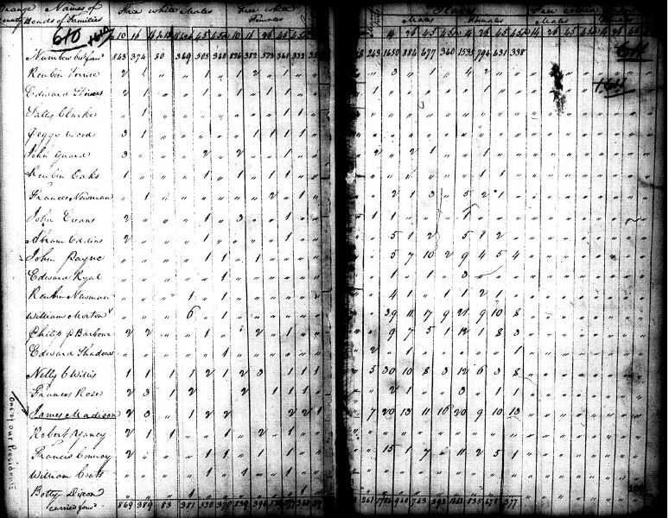

A recreation of the 1820 Census Questionnaire:

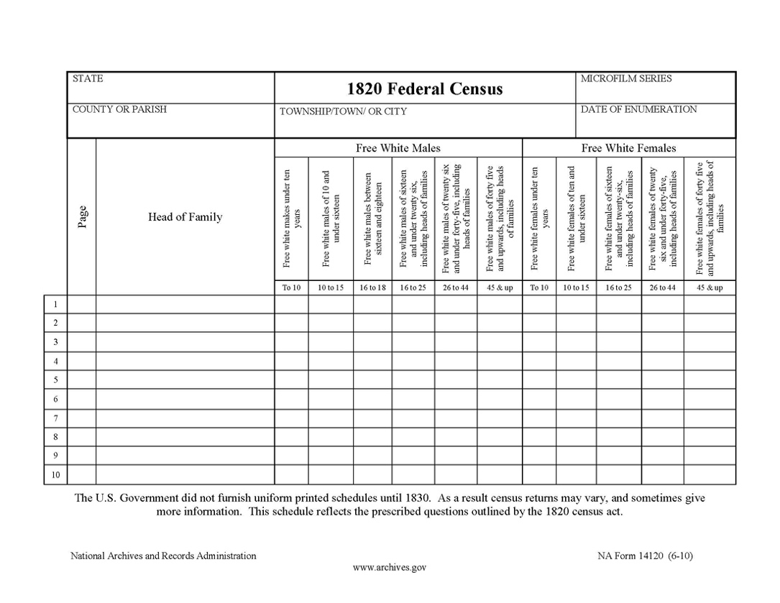

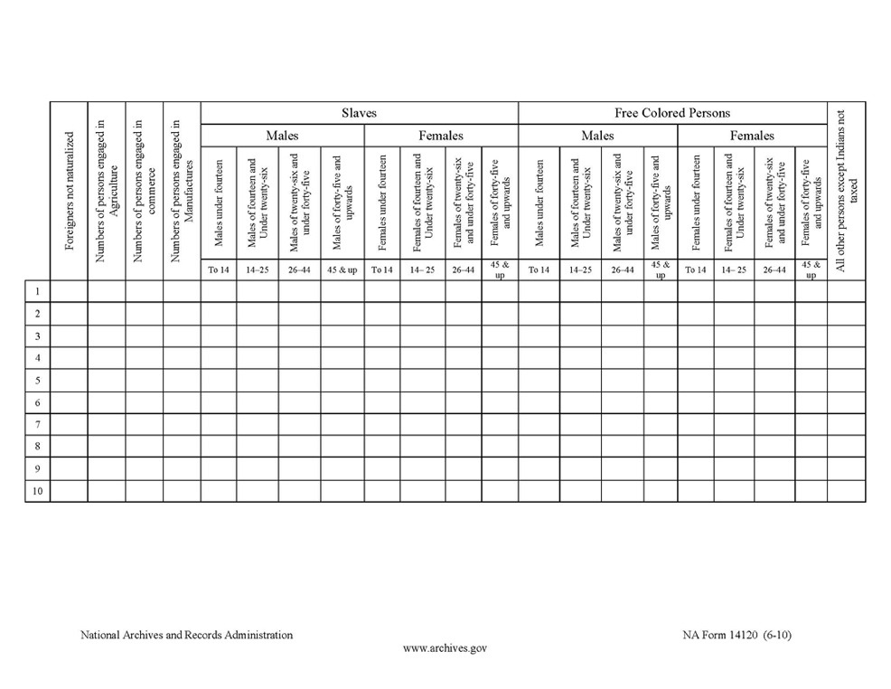

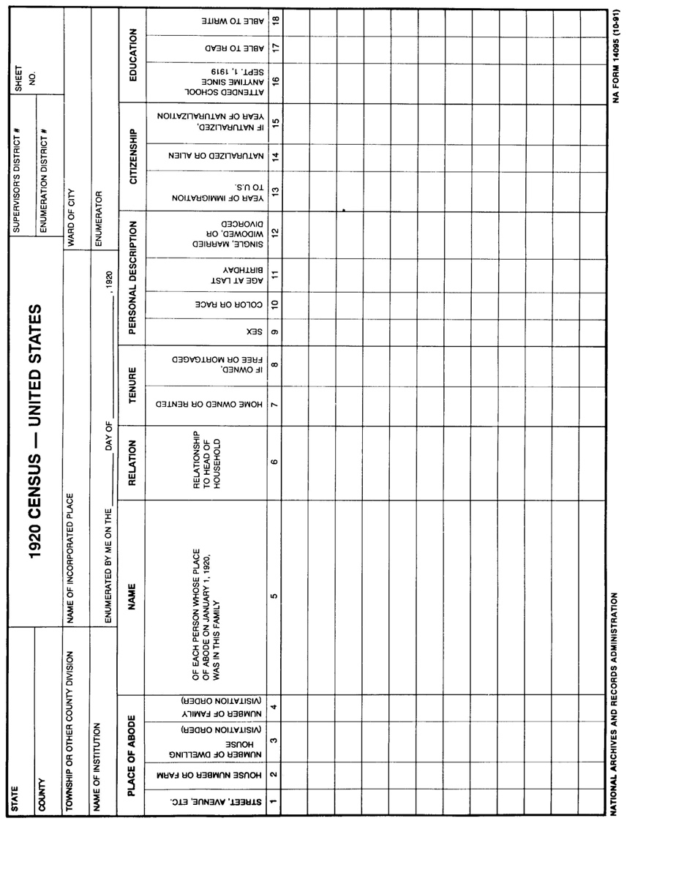100 years later for the 1920 census, "usual place of abode" became the basis for enumeration. Individuals were enumerated as residents of the place in which they regularly slept, not where they worked or might be visiting. People with no regular residence, including "floaters" and members of transient railroad or construction camps, were enumerated as residents of the place where they were when the count was taken.

# Page 2 of the 1920 U.S. Census Questionnaire

Now in 2020, the census form has changed dramatically, as has the wording of the questions on the questionnaire:

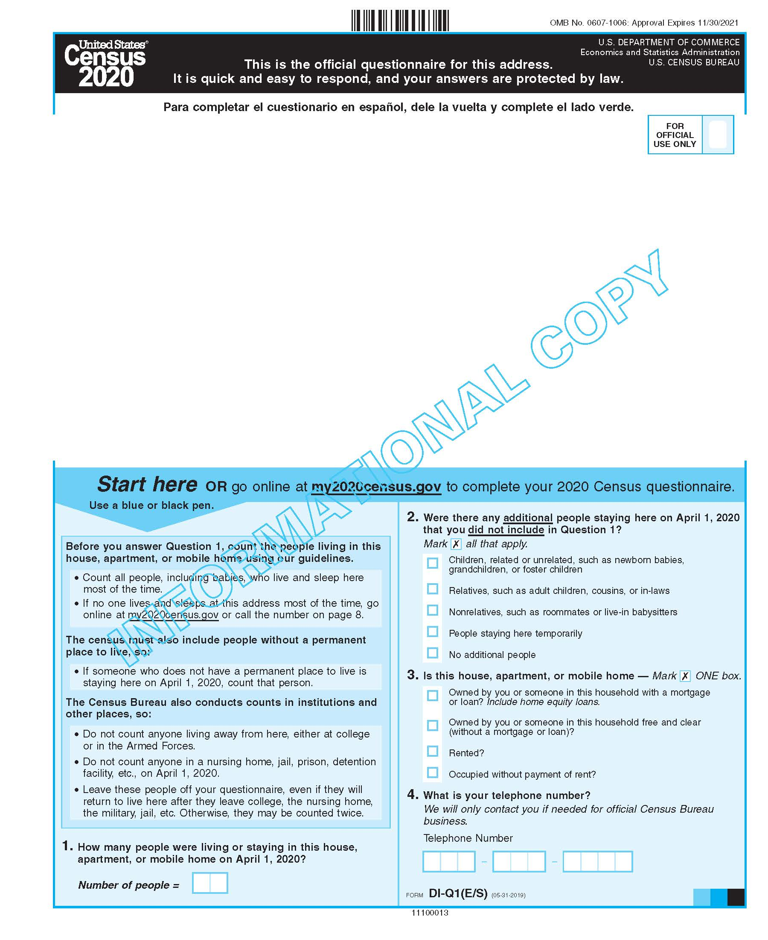

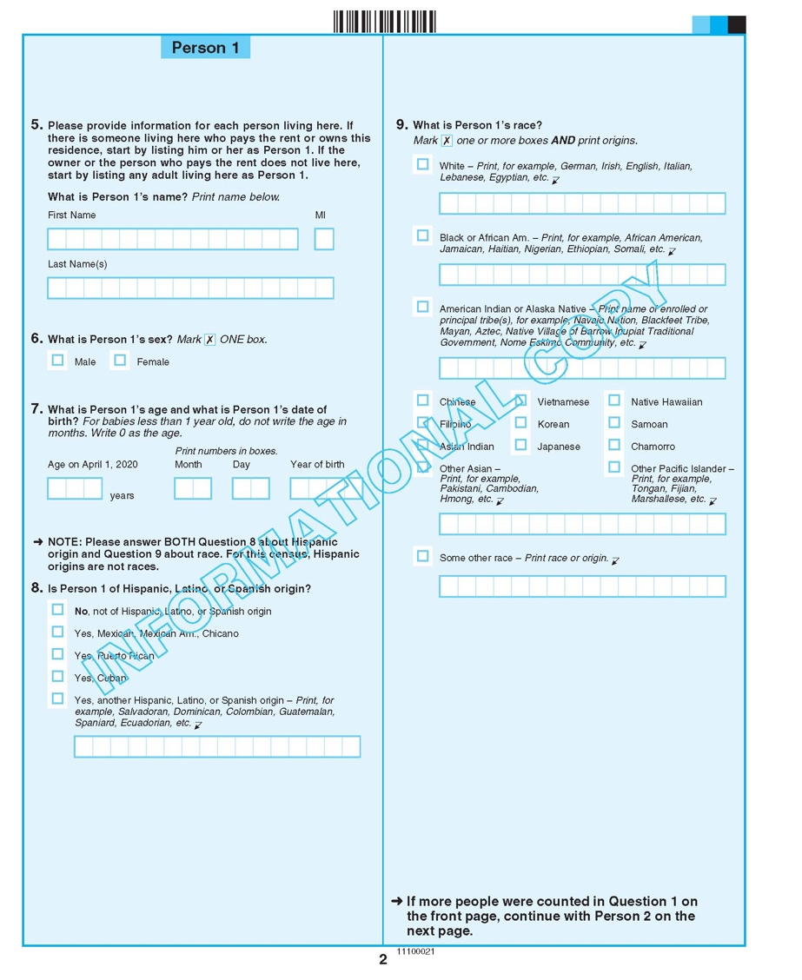

# Census 2020 – Why get counted?

## How census data is used:

To determine the distribution of Congressional seats to states

* Mandated by the U.S. Constitution
* Used to apportion seats in the U.S. House of Representatives
* Used to define legislature districts, school district assignment areas and other important functional areas of government

Find out about the [2020 Census Redistricting Data Program](https://www.census.gov/rdo/)

To make planning decisions about community services such as where to:

* Provide services for the elderly
* Build new roads and schools
* Locate job training centers

To distribute more than $675 billion in federal funds to local, state and tribal governments each year census data informs how states and communities allocate funding for:

* Neighborhood improvements
* Public health
* Education
* Transportation
* Much more

To provide Age Search information the [Age Search](https://www.census.gov/topics/population/genealogy/agesearch.html) service provides information for:

* Qualifying for Social Security and other retirement benefits
* Passport applications
* Proving relationship in settling estates
* Researching [family history](https://www.archives.gov/research/genealogy/) or a [historical topic](https://www.archives.gov/research/topics/)

United States Census Bureau, What We Do, May 2, 2019, (<https://www.census.gov/about/what.html#:~:text=To%20distribute%20more%20than%20%24675,Public%20health>)

# Ways to incorporate the census into your classroom or lesson plans:

The Census Bureau has already put together a number of [activities for grades 9-12](https://www.census.gov/programs-surveys/sis/2020census/2020-resources/k-12.Grades_9-12.html) which can be modified for use in your own curriculum in history, sociology, statistics, geography, economics, business, and more.

Probing questions such as:

1. Looking at the history timeline, what do you notice about census supervisors over the years and what might this tell us?
2. Why does the “race” box change over time? Why are people allowed to choose more than one box?
3. Using the “Fast Facts” page, what external factors might influence the changes in demographic counts or shifts?
4. What kind of information can we get from these census questionnaires about U.S. residents? What other or additional information do you think should be on these questionnaires and why?

[Statistics](https://www.census.gov/history/www/innovations/data_collection/developing_sampling_techniques.html): how is it used to determine demographic data throughout the years that are not census years?

[Technology](https://www.census.gov/history/www/innovations/technology/): How has the way in which data is collected changed over time and what sorts of data collection methods might work (better) in the future?

Past census Fast Facts: <https://www.census.gov/history/www/through_the_decades/fast_facts/>

Past census Questionnaires: <https://www.census.gov/history/www/through_the_decades/questionnaires/>